East Charity Shoal Light (offshore)
Jefferson County, Cape Vincent, New York 13618

East Charity Shoal Light, described on the attached fact sheet, has been determined to be excess to the needs of the United States Coast Guard (USCG). Pursuant to the National Historic Lighthouse Preservation Act (NHLPA) of 2000 16 U.S.C. 470, this property is being made available at no cost to eligible entities defined as federal, state and local agencies, non-profit corporations, educational agencies, or community development organizations for education, park, recreation, cultural, or historic preservation purposes.

In the event no applicant is approved as steward for the no cost conveyance, pursuant to Section 308 of the Act, the property will be offered for public sale. Historic covenants will be included in all deeds.

Any eligible entity with an interest in acquiring this property for a use consistent with the purposes stated above should submit a letter of interest to the address listed below by
September 23, 2008.

Letters of interest should include:
- Name of property
- Name of eligible entity
- Point of contact, title, address, phone and email
- Non-profit agencies must provide a copy of their state-certified articles of incorporation

Eligible entities that submit a letter of interest will be sent an application by the U.S. Department of the Interior and given an opportunity to inspect the property. Building inspectors and/or contractors may accompany the applicant for the inspection. The completed application must be submitted to the U.S. Department of the Interior National Park Service within 90 days of that inspection. The U.S. Department of the Interior will review applications and recommend a steward to receive the property. The U.S. General Services Administration will complete the conveyance to the recipient.

For more information on the National Historic Lighthouse Preservation Act, please visit the National Park Service website at http://www.cr.nps.gov/maritime/nhlpa/nhlpa.htm.

Letter of interest shall be directed to: A copy of the letter of interest shall be sent to:

Ms. Meta Cushing Ruth L. Pierpont, Director Field Services
U.S. General Services Administration State Historic Preservation Office
Property Disposal Division Peebles Island
10 Causeway Street, Room 925 Post Office Box 189
Boston, MA 02222 Waterford, NY 12188

GSA Control No. | 1-U-NY-0835
Property Identification | East Charity Shoal Light (offshore)
Address | 9.5 miles SW of Cape Vincent, Jefferson County NY 13618.  Marks the east side of Charity Shoals in northeastern Lake Ontario and located approximately 0.1 mile from the U.S.-Canadian international boundary. Marks hazardous shoals near the principal shipping lanes for vessels using the St. Lawrence Seaway.  Approx. Latitude: 44.033 Longitude: -76.466
Description  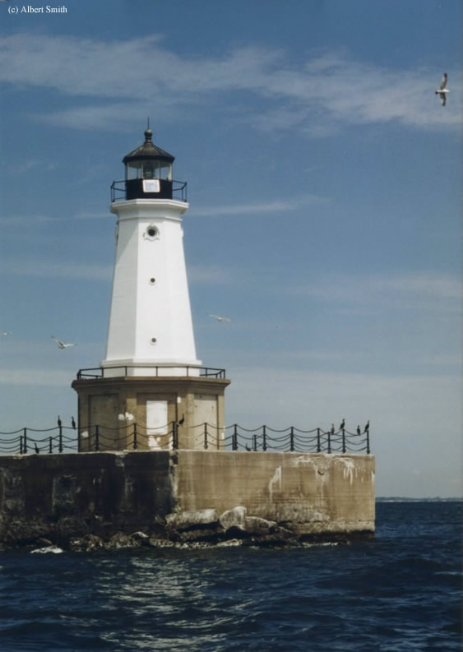  Picture courtesy of: Bryan Penberthy, us-lighthouses.com | Established in 1935. 56 feet tall; property includes a rectangular, reinforced concrete pier built on a wooden crib foundation with protective riprap; and a single-story octagonal concrete deckhouse with a three-story cast iron white tower topped with a lantern and lantern gallery (painted black). Deckhouse stands 11.5 feet tall and is approx. 20 feet in diameter. The concrete pier measures 50 feet long on each side and rises to approx. 18 feet above level of Lake Ontario. Interior of light includes a basement and five stories.
Condition of Property | The property is offered “AS IS’ and “WHERE IS”  without representation, warranty, or guarantee as to quality, quantity, title, character, condition, size or kind.
Range of Possible Uses | May be obtained for educational, park, recreational, cultural, or historic preservation purposes.
Commercial Activities | Commercial activities are prohibited unless approved by the Secretary of the Interior.
Historical Information | Property is listed on the National Register of Historic Places and must be maintained according to the Secretary of Interior’s Standards for Rehabilitation. Historic covenants will be incorporated into the deed.
Utilities | None
Current Tenant | None
Aid to Navigation (ATON) | ATON will remain the personal property of USCG. Automated beacon with solar array. Modern optic signals a white light flash once every four seconds. No fog signal horn.
Easements – to be retained by USCG | 1) An easement for the purpose of preserving an Arc of Visibility within the radial arc of 360 degrees with the stipulation that nothing will be constructed maintained or permitted of a height sufficient to interfere with or obstruct the Arc of Visibility of said light.  2) An easement for an unrestricted right of access for ingress and egress, to and across the Property to maintain, operate, service, repair, and replace equipment as necessary to support its ATON mission; and  3) The unrestricted right to relocate or add any aids to navigation or communications towers and equipment (along with necessary right of egress/ingress), or make any changes on any portion of the Property as may be necessary for navigation/public safety purposes.
Environmental Information | Due to the age of the structure, asbestos and lead-based paint may be present.
Notice Response Due Date | 60 days from the date of this Notice
Access/Inspection  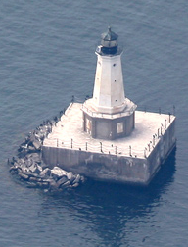  Picture Courtesy of: lighthousefriends.com | Access by boat only. Can be seen with binoculars from Tibbetts Point.  Inspection for eligible applicants will be arranged by US General Services Administration, Boston.
Contact | Meta Cushing: 617-565-5823 or meta.cushing@gsa.gov

